**Remote**

**access**

# Multi-user Remote Desktop and Application Delivery

TSplus Remote Access is a technology that caters to the requirements of both small and large businesses. Small businesses need a rich set of capabilities to minimize the cost of their IT efforts, while large businesses have complex IT Infrastructure demands. TSplus Remote Access solves these fundamental business problems by offering tailored remote Desktop and Application Delivery solutions designed for each of these business segments.

# Remote Desktop Access

Remote Access provides your remote and local users access to centralized Windows applications on a full remote desktop. Remote Access supports concurrent Remote Desktop (RDS) connections using HTML5 or any RDP compatible clients.

# Application Delivery

Publish Applications and enable users to remotely access them as if they were natively installed on their machine. Users access the remote apps from customizable launch menus or shortcuts on their desktops.

# Assigning Applications

Once you have published your applications, you can assign them to one or more users or groups. Administrators can assign applications based on Active Directory, local accounts, Azure or AWS.

# Multi-user Sessions

TSplus effectively enables from 3 to 50+ concurrent sessions to connect per server, allowing your server farm to scale up to thousands of users. Applications and connection modes can be customized for each user or group.

**Connection modes: Customize the User Experience**

**RDP Client**

TSplus Remote Access is compatible with any RDP client. Your concurrent users will have access to a standard Windows desktop with its shortcuts, start menu and task bar. Use the TSplus RDP client generator to enable a 1-click connection experience for your users.

# RemoteAPP Client

Provide a launch menu on the local desktop of users to open applications hosted on your server. Applications will be displayed on the user’s local desktop as if they were running locally, not in a remote desktop standard session. You can also decide to publish one single application that will start automatically on the user’s local desktop.

# HTML5 Client

The secure TSplus Web Portal enables delivery of a full remote desktop or application(s) on any device using any web browser. Users simply log in through the customizable HTML5 web portal to connect. The application(s) or the full desktop will be displayed within the browser.

# Display Options:

* RDP – Full Desktop with MSTSC or TSplus 1-click
* RemoteApp - Floating Panel or Application Panel
* RemoteApp – One-application launch
* HTML5 - Full Desktop or One-application launch
* HTML5 – Web Portal or Progressive Web App

https://tsplus.net/remote-access

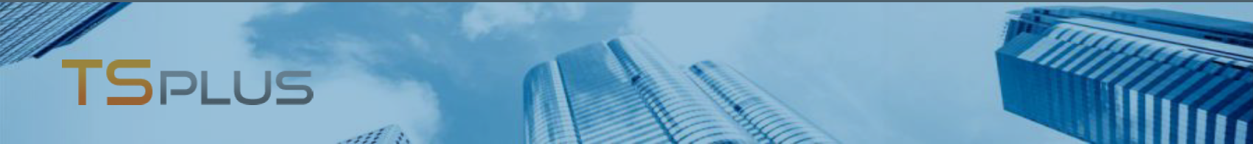

# Pre-Requisites:

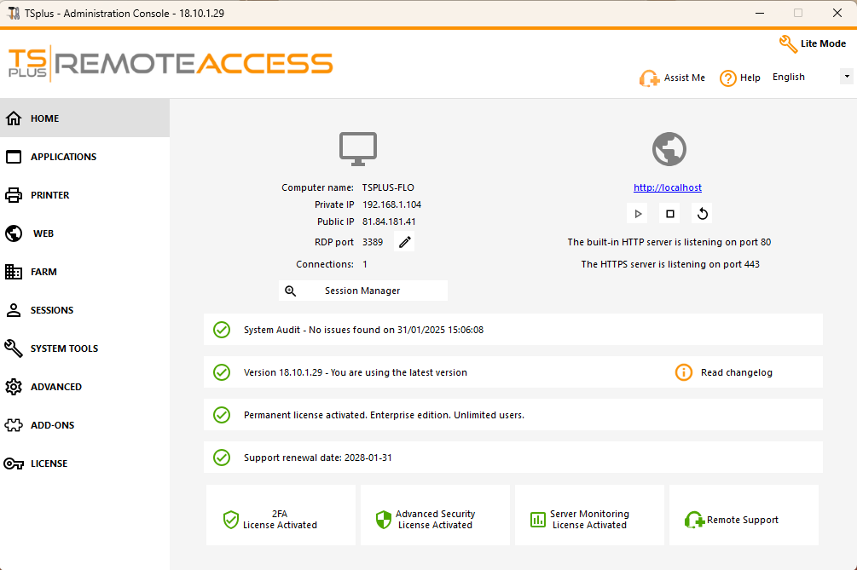

1. Hardware

TSplus Remote Access Server minimum requirements:

|  |  |
| --- | --- |
| **Number of users** | **Windows Server2008 to 2025 or 7 to 11 Pro** |
| 3 - 5 | I5 or above 4-8 GB RAM  One CPU 2 GHZ |
| 10 | I5 or above 8-16 GB RAM  One CPU 2 GHZ |
| 25 | I7 or Xeon  16-32 GB RAM  One CPU |
| 50 and above | Dual CPU  32-64 GB RAM  SSD Disk dedicated to the system |

# Admin Tool

Configure all Remote Access tools in one place.

* User and Application Management
* Active Directory Support
* Client Generator
* Customizable Web Portal with Real-time Preview

# Remote Printing

Print from a remote session to a local printer.

* Universal Printer (driverless remote printing with pdf)
* Virtual Printer (fine-tuning and advanced printing)

# Security

Maximize the security of your remote access infrastructure.

* Secure encrypted connections (SSL/TLS)
* TSplus Advanced Security (all-in-one security toolbox for remote access – add-on)
* Two-factor Authentication (add-on to the Web Portal)
* Frequent Security Updates
* Lockout Feature (monitor and block IP after too many failed login attempts)

# Farm Management

Scale up your remote access infrastructure.

* TSplus Gateway Portal (access to multiple servers from one place)
* Load Balancing
* Reverse Proxy
* Applications and Settings Synchronization

# …And More:

* Web credentials
* Session Pre-launch
* File transfer and Clipboard
* Open on Client
* Customers and Partners Licensing Portal

1. Operating system

Your server must use one of the following operating systems:

* + Windows 7 Service Pack 1, 8/8.1, 10 Pro, or 11 Pro
  + Windows Server 2008 SP2 or R2 SP1, Server 2012 or 2012 R2, Server 2016, Server 2019, Server 2022 or Server 2025

Both 32- and 64-bit operating systems are supported. The required framework is .NET version 4.7.2 for all supported Windows versions.

Make sure the RDS/Terminal Services and RDS/ Terminal Services Licensing server roles are not installed.

Windows Home/Family Editions are not supported.

1. Network parameters

The Remote Access Server must have a static private IP address

The TCP RDP port (by default 3389) must be opened both ways on your firewall.

**The trial version of Remote Access is the fully featured Enterprise Edition. It is licensed for up to 5 concurrent users for a period of 15 days**.

**Contact us**

Name:

Address:

Tel:

Email:

https://tsplus.net/remote-access